**The happiness of the elderly**

Abstract

Recently, most of the society is ageing, and the happiness of the elderly is the key to successful ageing. Finding the factors that affect the happiness of the elderly can improve the understanding of the happiness of the elderly and help improve the degree of happiness. This study first uses descriptive statistics to analyze the variables. Use the chi-square result to get the results: depression, age, gender, marital status, living with grandchildren, and disability have a significant impact on happiness, but there is no significant relationship between retirement age. Logistic regression results show that only depression, age, marital status, and disability are significantly related to happiness

Zhibo Liu

Reg number: 210164972

Word count: 2629

Content

1. Introduction 3

2. Literature review 4

2.1 Living with grandchildren 4

2.2 Disability 4

2.3 Depression 4

2.4 Retirement 5

2.5 Marital status 5

2.6 Age and gender 5

3. Methodology 5

3.1 ELSA 5

3.2 Descriptive statistic 6

3.3 Inferential statistic 6

3.4 Summary 7

4. Results 9

4.1 Description statistic and Chi-squared test 9

4.1.1 Happiness 9

4.1.2 Age 10

4.1.3 Gender 11

4.1.4 Living with grandchildren 12

4.2 Binary logistic regression 17

5. Discussion 19

6. Conclusion 19

References: 20

Appendix 23

# 1. Introduction

Due to the ever-improving quality of life and the ever-improving medical standards, our world is developing into an ageing society. Recently, more literature (Khazaee-pool et al., 2016; Cameron et al., 2018; Li et al., 2021; Campen & Santvoort, 2013; Luchesi et al., 2018; Lima & Goi, 2012) has focused on the subjective well-being of the elderly Sense. According to Cordeiro, Mota, Ribeiro, and Quintino (2016), feeling unhappy is seen as a huge obstacle to the enjoyment of life by older people. Therefore, whether to feel happy has become one of the main problems of the elderly. Subjective well-being indicates whether an individual is satisfied with their overall quality of life (Hidaka et al., 2020). Whether happiness can be used to measure the quality of life of the elderly is an important indicator of the successful ageing of society (Hidaka et al., 2020; Campen & Santvoort, 2013; Molashahri et al., 2015).

In addition, regarding the factors that affect happiness, Khazaee-pool et al. (2016) stated that active participation in sports activities can improve the happiness of the elderly. Choi (2021) mentioned that depression is necessarily related to feelings of happiness in the elderly. In addition to the need to intervene in the depression of the elderly, it is also necessary to use leisure and entertainment. Moreover, Shah et al. (2021) and Hidaka et al. (2020) added that the active participation of the elderly in social activities can keep their happiness at a high level. In addition to these factors, many situations affect happiness. For example, Mountian and Diaz (2020) and Kesavayuth and Zikos (2020) all believe that there is a causal relationship between elderly retirement and happiness, and more explanations are needed. In addition, previous research also indicated that elderly people living with grandchildren or granddaughters in China have a higher degree of happiness (Chyi & Mao, 2011). The results of these numerous articles in the past indicate that the happiness of the elderly is affected by many factors. Therefore, this report aims to explore the factors that affect the happiness of the elderly. The author selected several potential factors from wave 7 of the English Longitudinal Study of Ageing (ELSA) dataset for research.

This article is divided into six parts. The first and second parts introduce the aims of this article and the work of the past literature. The third part explains the methodology of the research. The fourth part shows the results. Then there is the discussion, and finally the summary of the full text.

# 2. Literature review

## 2.1 Living with grandchildren

According to research conducted by Chyi and Mao (2011), they stated that compared with the elderly living with their children, they will achieve a higher degree of happiness when living with their grandchildren. Similarly, the results of Dunifon, Musick and Near (2019) also show that the elderly are happier when they live with their grandchildren than when they are alone. This may be because the elderly’s emotional support from their grandchildren has a positive impact on their happiness. Therefore, the elderly living with their grandchildren may have an impact on their happiness to a certain extent.

## 2.2 Disability

Many studies in the past have shown the relationship between disability and subjective well-being in the elderly. For example, Lima & Goi (2012) mentioned that more elderly people without disabilities have longer periods of happiness. Luchesi et al. (2018) also indicated that the satisfaction with life of the aged has a significant relationship with disability. Goudarzian et al. (2020) supplemented this view, stating that the higher the disability level of the elderly, the higher the anxiety, which will reduce their satisfaction and optimism in life, that is, less happiness. Therefore, it is necessary to study the extent to which disability affects happiness.

## 2.3 Depression

Past studies have shown that in addition to paying attention to the physical health of the elderly, more attention should be paid to mental health. This is because the unhappiness of the elderly is related to severe depression (Tastan et al., 2019). Luchesi et al. (2021) pointed out that the happiness of the elderly is significantly related to depression. Martínez et al. (2018) analyzed the data obtained by using Short Depression-Happiness Scale to verify this view. Thus, depression is an important factor that affects the happiness of the elderly.

## 2.4 Retirement

Retirement is an inevitable experience for the elderly in most countries. It is also an important life course change, and the health and economy of the elderly will be changed (Kesavayuth, Rosenman & Zikos, 2018). In a past study, Mountian and Diaz (2020) proposed that retirement may affect the health of the elderly, thereby affecting the feeling of happiness. However, after retirement, their satisfaction with life will increase and may not be affected by the length of time after retirement (Kesavayuth, Rosenman & Zikos, 2020). Therefore, it is necessary to understand whether retirement time affects happiness.

## 2.5 Marital status

The marriage of the elderly is also an important factor. Cox and Sim-Cox (2021) show that marital status is closely related to happiness. Raymo (2015) also stated that compared with the family living with a loved one, the happiness of living alone is significantly lower. Therefore, different marital status has different effects on the happiness of the elderly.

## 2.6 Age and gender

Different gender and age will also have an impact. For example, Luchesi et al. (2018) indicated that the happiness of the elderly has a significant relationship with their age. And gender also has this significant relationship, so the degree of influence on the happiness of men and women is different (Rijavec, Jurcec & Mijocevic, 2010). Therefore, the age and gender of the elderly affect happiness to a certain extent.

# 3. Methodology

This section will introduce the methodology used to achieve the aim of this research. It introduces wave 7 of the English Longitudinal Study of Ageing (ELSA) dataset and two statistical techniques used. All analyses were conducted using SPSS software version 27.

## 3.1 ELSA

This study uses the Wave 7 data set of the Longitudinal Study on Aging in the United Kingdom (ELSA). The collection of this data set started in June 2014 and ended in May 2015. The study collected data from 9666 participants to provide data related to diseases and disabilities of the elderly (Banks et al., 2016). The data set contains a wide range of data, such as gender, anxiety, marital status, and economic status.

Before performing subsequent analysis, re-encode the used data into a suitable form. First, classify age indager and retirement age WpRAge into four parts and recode them as indager_da and WpRAge_da (1="50 to 59", 2="60 to 69", 3="70 to 79", 4="80 to 89"). Then convert happiness PScedD, whether to live with grandchildren grinhh, whether disabled HeLWk, and depression PScedA into binary data type (0=No, 1=Yes). Finally, the marriage situation is summarized into four values (0 = "Widowed", 1 = "Single", 2 = "Married", 3 = "Divorced"). All used variables and recoded variables are shown in Table 1.

## 3.2 Descriptive statistic

The first technique used is descriptive statistics. Use descriptive statistics to analyze all variables under study. Using descriptive statistical analysis can help understand the distribution of data and insights. Therefore, the author used a histogram to show the frequency distribution of age (indager_da), marital status (DiMar_da), and retirement age (WpRAge_da). Use pie charts to show the categories and proportions of gender (sex_da), happiness (PScedD_da), living with grandchildren (grinhh_da), disability (HeLWk_da) and depression (PScedA).

## 3.3 Inferential statistic

Since all variables used in this study are categorical variables, the author uses non-parametric tests for research. This article mainly uses two test methods. The first is the Chi-Squared test, which is used to sequentially test whether the relationship between all independent variables and dependent variable happiness is significant. The second method is binary logistic regression. Although Chi-square has been used to test the relationship between each variable and happiness, since each variable may affect each other, the author uses logistic regression to test whether the relationship between them is significant. Therefore, the author uses logistic regression to analyze the direct relationship between elderly happiness and gender (sex_da), living with grandchildren (grinhh_da), disability (HeLWk_da) and depression (PScedA), age (indager_da) and marital status (DiMar_da). Table 1 shows the Null hypothesis H0 in Chi-Squared.

## 3.4 Summary

Table 1 below summarizes all variables and recoded variables used, the label of variables, value of them, statistic method and Null hypothesis H0.

Table 1 summary of used variables

|  |  |  |  |  |  |  |
| --- | --- | --- | --- | --- | --- | --- |
| variable | Value | Description | Recoded variable | Recoded value | Inferential statistic | Null hypothesis H0 |
| PScedD | -9=Refusal  -8=Don’t Know  -2=Schedule not applicable  -1=Item not applicable  1=Yes  2=No | Whether was happy much of the time during past week | PScedD_da | 0=No  1=Yes | Binary logistic regression |  |
| indager | -7 = Age of 90 or over collapsed to avoid disclosure | Definitive age variable collapsed at 90+ to avoid disclosure | indager_da | 1=50-59  2=60-69  3=70-79  4=80-89 | Chi-squared test | There is association between happiness and age |
| indsex | 1 = Male  2 = Female | Definitive sex variable: priority  disex, dhsex | indsex_da | 0=Female  1=Male | Chi-squared test | There is association between happiness and gender |
| gcinhh | 1=Yes  2=No | Whether respondent has a grandchild in the household | gcinhh_da | 0=No  1=Yes | Chi-squared test | There is association between happiness and living with grandchildren |
| HeLWk | -9=Refusal  -8=Don’t Know  -2=Schedule not applicable  -1=Item not applicable  1=Yes  2=No | Whether has self-reported health problem/disability that limits paid work | HeLWk_da | 0=No  1=Yes | Chi-squared test | There is association between happiness and disability |
| WpRAge | None | You said earlier that you were (semi-)retired, at what age did you retire? | WpRAge_da | 1=50-59  2=60-69  3=70-79  4=80-89 | Chi-squared test | There is association between happiness and retire age |
| DiMar | -9=Refusal  -8=Don’t Know  -2=Schedule not applicable  -1=Item not applicable  1=Single  2=Married  …  6=Divorced  7=Widowed | Respondent current legal marital status | DiMar_da | 0=Widowed  1=Single  2=Married  3=Divorced | Chi-squared test | There is association between happiness and marital status |
| PScedA | -9=Refusal  -8=Don’t Know  -2=Schedule not applicable  -1=Item not applicable  1=Yes  2=No | Whether felt depressed much of the time during past week | PScedA_da | 0=No  1=Yes | Chi-squared test | There is association between happiness and depression |

# 4. Results

## 4.1 Description statistic and Chi-squared test

### 4.1.1 Happiness

Figure 1 and Table 2 show the descriptive statistical analysis of the variable happiness (PScedD_da). For this variable, 0 means unhappiness and 1 means happiness. Among all the data, 90.3% of people said they felt happy after removing unavailable data, and only 9.7% felt unhappy.

|  |  |  |  |  |  |
| --- | --- | --- | --- | --- | --- |
| **Table 2 Happiness** | | | | | |
|  | | Frequency | Percent | Valid Percent | Cumulative Percent |
| Valid | .00 | 869 | 9.0 | 9.7 | 9.7 |
| 1.00 | 8109 | 83.9 | 90.3 | 100.0 |
| Total | 8978 | 92.9 | 100.0 |  |
| Missing | System | 688 | 7.1 |  |  |
| Total | | 9666 | 100.0 |  |  |

**Figure 1**

### 4.1.2 Age

Figure 2 and Table 3 are descriptive statistical analyses of age variables. The variable integer_da uses 1 to represent 50 to 59 years old, 2 to 60 to 69 years old, 3 to 70 to 79 years old, and 4 to 80 to 89 years old. Figure 2 shows the frequency distribution of age classification. The highest proportion of the age group is 60 to 69 years old, 39%, which is the main population in the data. Then there are 70 to 79 years old and 50 to 59 years old, respectively. 27 and 22.4% of the total, while those between 80 and 89 years old accounted for only 11.5% (1=50-59, 2=60-69, 3=70-79, 4=80-89).

Table 4 shows the Chi-squared test of variable integer_da. The result indicates that the p-value is less than 0.001, which means that the null hypothesis H0 (There is an association between happiness and age) can be rejected, and age has a significant relationship with happiness (χ2=20.393a; df=3; p<0.001; none of Ei is less than 5).

|  |  |  |  |  |  |
| --- | --- | --- | --- | --- | --- |
| **Table 3 age group** | | | | | |
|  | | Frequency | Percent | Valid Percent | Cumulative Percent |
| Valid | 1.00 | 2082 | 21.5 | 22.4 | 22.4 |
| 2.00 | 3630 | 37.6 | 39.0 | 61.4 |
| 3.00 | 2515 | 26.0 | 27.0 | 88.5 |
| 4.00 | 1071 | 11.1 | 11.5 | 100.0 |
| Total | 9298 | 96.2 | 100.0 |  |
| Missing | System | 368 | 3.8 |  |  |
| Total | | 9666 | 100.0 |  |  |

**Figure 2**

**Table 4 Chi-squared for happiness and age**

|  |  |  |  |
| --- | --- | --- | --- |
|  | Value | df | Asymptotic Significance  (2-sided) |
| Pearson Chi-Square | 20.393a | 3 | <.001 |

a. 0 cells (0.0%) have expected count less than 5. The minimum expected count is 94.30.

### 4.1.3 Gender

According to the results in Table 5 and Figure 3, 55.5 percent of the gender of the respondents in the NLSA data are female (0=Female) and 44.5 percent are male (1=Male). Table 6 shows the results of the Chi-squared. p is less than 0.001, so it can reject the null hypothesis that there is no correlation between happiness and gender. There is a significant relationship between happiness and gender (χ2=12.363a; df=1; p<0.001; none of Ei is less than 5).

|  |  |  |  |  |  |
| --- | --- | --- | --- | --- | --- |
| **Table 5 gender** | | | | | |
|  | | Frequency | Percent | Valid Percent | Cumulative Percent |
| Valid | .00 | 5368 | 55.5 | 55.5 | 55.5 |
| 1.00 | 4298 | 44.5 | 44.5 | 100.0 |
| Total | 9666 | 100.0 | 100.0 |  |

**Figure 3**

**Table 6 Chi-squared for happiness and gender**

|  |  |  |  |
| --- | --- | --- | --- |
|  | Value | df | Asymptotic Significance  (2-sided) |
| Pearson Chi-Square | 12.363a | 1 | <.001 |

a. 0 cells (0.0%) have expected count less than 5. The minimum expected count is 380.88.

### 4.1.4 Living with grandchildren

From Table 7 and Figure 4, it is obvious that the number of elderly people with grandchildren in the NLSA dataset only accounts for 2.5% of the total, and 97.5% of them do not live with their grandchildren (0=No, 1 =Yes). The p-value in the Chi-squared results in Table 8 is 0.028. Since it is less than 0.05, we can reject the null hypothesis that happiness is not related to living with grandchildren. Therefore, there is a significant correlation between living with grandchildren and happiness (χ2=4.843a; df=1; p=0.028; none of Ei is less than 5).

|  |  |  |  |  |  |
| --- | --- | --- | --- | --- | --- |
| **Table 7 living with grandchildren** | | | | | |
|  | | Frequency | Percent | Valid Percent | Cumulative Percent |
| Valid | .00 | 9429 | 97.5 | 97.5 | 97.5 |
| 1.00 | 237 | 2.5 | 2.5 | 100.0 |
| Total | 9666 | 100.0 | 100.0 |  |

**Figure 4**

**Table 8 Chi-squared for happiness and living with grandchildren**

|  |  |  |  |
| --- | --- | --- | --- |
|  | Value | df | Asymptotic Significance  (2-sided) |
| Pearson Chi-Square | 4.843a | 1 | 0.028 |

|  |
| --- |
| a. 0 cells (0.0%) have expected count less than 5. The minimum expected count is 20.62. |

4.1.5 Disability

In addition to the missing data, Table 9 shows that there are 6354 elderly people without disabilities, accounting for 70% of the total. The elderly with disabilities account for 29.8% of the total. The p-value obtained by the Chi-squared test in Table 10 is less than 0.001, so the null hypothesis can be rejected and there is a significant relationship between happiness and disability (χ2=231.306a; df=1; p<0.001; none of Ei is less than 5).

|  |  |  |  |  |  |
| --- | --- | --- | --- | --- | --- |
| **Table 9 disability** | | | | | |
|  | | Frequency | Percent | Valid Percent | Cumulative Percent |
| Valid | .00 | 6354 | 65.7 | 70.2 | 70.2 |
| 1.00 | 2703 | 28.0 | 29.8 | 100.0 |
| Total | 9057 | 93.7 | 100.0 |  |
| Missing | System | 609 | 6.3 |  |  |
| Total | | 9666 | 100.0 |  |  |

**Figure 5**

**Table 10 Chi-squared for happiness and disability**

|  |  |  |  |
| --- | --- | --- | --- |
|  | Value | df | Asymptotic Significance  (2-sided) |
| Pearson Chi-Square | 231.306a | 1 | <.001 |

|  |
| --- |
| a. 0 cells (0.0%) have expected count less than 5. The minimum expected count is 257.49. |
|  |

4.1.6 Retirement

This section shows a statistical analysis of the frequency of retirement age data. The data is divided into 1 to represent 50 to 59 years old, 2 to 60 to 69 years old, 3 to 70 to 79 years old, and 4 to 80 to 89 years old. The number of people who retire between the ages of 60 and 69 is 66.2% of all, which is the largest. Retirement between the ages of 80 and 89 is only 0.5%, five people. Table 12 shows the results of the Chi-squared. Since the p-value of 0.597 is much greater than 0.05, the null hypothesis cannot be rejected, and there is no correlation between happiness and retirement age (χ2=1.884a; df=3; p=0.597; 37.5% of Ei is less than 5).

|  |  |  |  |  |  |
| --- | --- | --- | --- | --- | --- |
| **Table 11 retirement age** | | | | | |
|  | | Frequency | Percent | Valid Percent | Cumulative Percent |
| Valid | 1.00 | 273 | 2.8 | 28.6 | 28.6 |
| 2.00 | 632 | 6.5 | 66.2 | 94.9 |
| 3.00 | 44 | .5 | 4.6 | 99.5 |
| 4.00 | 5 | .1 | .5 | 100.0 |
| Total | 954 | 9.9 | 100.0 |  |
| Missing | System | 8712 | 90.1 |  |  |
| Total | | 9666 | 100.0 |  |  |

**Figure** 6

**Table 12 Chi-squared for happiness and retirement age**

|  |  |  |  |
| --- | --- | --- | --- |
|  | Value | df | Asymptotic Significance  (2-sided) |
| Pearson Chi-Square | 1.884a | 3 | .597 |

|  |
| --- |
| a. 3 cells (37.5%) have expected count less than 5. The minimum expected count is .28. |

4.1.7 Marital status

The marital status data is divided into Widowed (0), Single (1), Married (2) and Divorced (3) by value. From Table 13 and Figure 7, among the elderly, the number of people in the married state is the largest, accounting for 63.3%. The number of single persons is 7.4%, which is the least. The results of Chi-squared in Table 14 indicate that the p-value is less than 0.001. Therefore, the null hypothesis can be rejected, and the marital status is significantly related to happiness (χ2=113.663a; df=3; p<0.001; none of Ei is less than 5).

|  |  |  |  |  |  |
| --- | --- | --- | --- | --- | --- |
| **Table 13 Marital status** | | | | | |
|  | | Frequency | Percent | Valid Percent | Cumulative Percent |
| Valid | .00 | 1405 | 14.5 | 16.6 | 16.6 |
| 1.00 | 624 | 6.5 | 7.4 | 24.0 |
| 2.00 | 5362 | 55.5 | 63.3 | 87.3 |
| 3.00 | 1079 | 11.2 | 12.7 | 100.0 |
| Total | 8470 | 87.6 | 100.0 |  |
| Missing | System | 1196 | 12.4 |  |  |
| Total | | 9666 | 100.0 |  |  |

**Figure 7**

**Table 14 Chi-squared for happiness and marital status**

|  |  |  |  |
| --- | --- | --- | --- |
|  | Value | df | Asymptotic Significance  (2-sided) |
| Pearson Chi-Square | 113.663a | 3 | <.001 |

|  |
| --- |
| a. 0 cells (0.0%) have expected count less than 5. The minimum expected count is 59.08. |

4.1.8 Depression

This part is an analysis of depression variables, PScedA_da(0=No,1=Yes). According to Table 15 and Figure 8, the number of elderly people who are not depressed accounts for 88.4% of the total, and only 1,000 people have depression. Case. Table 16 shows the results of the Chi-squared test. The p-value is less than 0.001, so you can reject the null hypothesis and show that there is a significant relationship between depression and the happiness of the elderly (χ2=1956.922a; df=1; p<0.001; none of Ei is less than 5).

|  |  |  |  |  |  |
| --- | --- | --- | --- | --- | --- |
| **Table 15 depression** | | | | | |
|  | | Frequency | Percent | Valid Percent | Cumulative Percent |
| Valid | .00 | 7958 | 82.3 | 88.4 | 88.4 |
| 1.00 | 1043 | 10.8 | 11.6 | 100.0 |
| Total | 9001 | 93.1 | 100.0 |  |
| Missing | System | 665 | 6.9 |  |  |
| Total | | 9666 | 100.0 |  |  |

**Figure 8**

**Table 16 Chi-squared for happiness and depression**

|  |  |  |  |
| --- | --- | --- | --- |
|  | Value | df | Asymptotic Significance  (2-sided) |
| Pearson Chi-Square | 1956.922a | 1 | .000 |

|  |
| --- |
| a. 0 cells (0.0%) have expected count less than 5. The minimum expected count is 100.56. |
|  |

## 4.2 Binary logistic regression

This part shows the results of logistic regression. Since all the independent variables are categorical, they are transferred to dummy variables (shown in Table 19). The null hypothesis is that the happiness of the elderly has no relationship with these six variables.

From Table 17, Nagelkerke R Square is 0.304, which means that 30.4% of the happiness variation is explained by the 6 independent variables in the model, which are depression, age, gender, marital status, living with grandchildren, and disability.

Table 18 shows that only the p-value of the two variables of gender and grandchildren life is greater than 0.05, so the null hypothesis can be rejected. Depression, age, marital status, and disability are significantly related to happiness and have a significant predictive effect in the model. Among them, the strongest predictor of depression, when other conditions remain unchanged, the probability of happiness of non-depressed elderly people is 15.675 times the probability of happiness of depressed elderly people. In addition, in age and marital status, only the factors of 50 to 69 years and marriage have a predictive effect. For example, under the control of other conditions, married elderly people are 1.624 times more likely to be happy than divorced elderly people. People without disabilities are 1.825 times more likely to be happier than elderly people with disabilities.

|  |  |  |  |
| --- | --- | --- | --- |
| **Table 17 Model Summary** | | | |
| Step | -2 Log likelihood | Cox & Snell R Square | Nagelkerke R Square |
| 1 | 3713.045a | .145 | .304 |

a. Estimation terminated at iteration number 6 because parameter estimates changed by less than .001.

**Table 18 Logistic regression for happiness and six independent variables**

|  |  |  |  |  |  |  |  |  |
| --- | --- | --- | --- | --- | --- | --- | --- | --- |
|  | B | S.E. | Wald | df | Sig. | Exp(B) | 95% C.I. for EXP(B) Lower | 95% C.I. for EXP(B) Upper |
| depression(1) | 2.752 | .093 | 874.425 | 1 | .000 | 15.675 | 13.061 | 18.811 |
| age group |  |  | 14.346 | 3 | .002 |  |  |  |
| age group(1) | -.554 | .167 | 11.019 | 1 | .001 | .575 | .414 | .797 |
| age group(2) | -.318 | .154 | 4.238 | 1 | .040 | .728 | .538 | .985 |
| age group(3) | -.138 | .153 | .813 | 1 | .367 | .871 | .645 | 1.176 |
| gender(1) | -.049 | .093 | .284 | 1 | .594 | .952 | .794 | 1.141 |
| Marital status |  |  | 36.978 | 3 | .000 |  |  |  |
| Marital status(1) | .253 | .156 | 2.639 | 1 | .104 | 1.288 | .949 | 1.749 |
| Marital status(2) | -.303 | .170 | 3.170 | 1 | .075 | .738 | .529 | 1.031 |
| Marital status(3) | .485 | .123 | 15.639 | 1 | .000 | 1.624 | 1.277 | 2.065 |
| living with grandchildren(1) | .083 | .264 | .099 | 1 | .753 | 1.087 | .647 | 1.825 |
| disability(1) | .602 | .093 | 41.985 | 1 | .000 | 1.825 | 1.521 | 2.189 |
| Constant | -.250 | .320 | .610 | 1 | .435 | .779 |  |  |

|  |  |  |  |  |  |
| --- | --- | --- | --- | --- | --- |
| **Table 19 Categorical Variables Codings** | | | | | |
|  | | Frequency | Parameter coding | | |
| (1) | (2) | (3) |
| age group | 1.00 | 1631 | 1.000 | .000 | .000 |
| 2.00 | 2928 | .000 | 1.000 | .000 |
| 3.00 | 2104 | .000 | .000 | 1.000 |
| 4.00 | 919 | .000 | .000 | .000 |
| Marital status | .00 | 1213 | 1.000 | .000 | .000 |
| 1.00 | 557 | .000 | 1.000 | .000 |
| 2.00 | 4790 | .000 | .000 | 1.000 |
| 3.00 | 1022 | .000 | .000 | .000 |
| disability | .00 | 5360 | 1.000 |  |  |
| 1.00 | 2222 | .000 |  |  |
| gender | .00 | 4267 | 1.000 |  |  |
| 1.00 | 3315 | .000 |  |  |
| living with grandchildren | .00 | 7403 | 1.000 |  |  |
| 1.00 | 179 | .000 |  |  |
| depression | .00 | 6705 | 1.000 |  |  |
| 1.00 | 877 | .000 |  |  |

# 5. Discussion

In general, these results are similar to the results of existing studies on the happiness of the elderly. The research on depression, age, marital status and disability is consistent with the results of past research, and the impact on the happiness of the elderly is significant (Luchesi et al., 2018; Luchesi et al., 2021; Raymo, 2015; Goudarzian et al., 2020). However, contrary to the results of Rijavec, Jurcec and Mijocevic (2010), gender and happiness are not significantly related, which may be because their research subjects are not only the elderly. Moreover, living with grandchildren is also different from Dunifon, Musick and Near (2019), and it is not significant.

There are still some limitations in this article. This is due to the data set used. There are some missing data in the data used, and the problem setting of the variable may be inappropriate. All of these may have an impact on the relevance. Therefore, more variables or more accurate data should be tried in future research.

# 6. Conclusion

This report is mainly to find the factors that affect the happiness of the elderly. Chi-squared results indicate that depression, age, gender, marital status, living with grandchildren, and disability have a significant effect on happiness, but retirement age has no significant relationship. Logistic regression results indicate only depression, age, marital status, and disability are significantly related to happiness.

# References:

Banks, J., Batty, G. D., Nazroo, J. Y., & Steptoe, A. (2016). The dynamics of ageing: Evidence from the English Longitudinal Study of Ageing 2002-15.

Cameron, I. D., Dyer, S. M., Panagoda, C. E., Murrary, G. R., Hill, K. D., Cumming, R. G., & Kerse, N. (2018) Interventions for preventing falls in older people in care facilities and hospitals. *Cochrane Database of Systematic Reviews, 9.* https://doi.org/10.1002/14651858.CD005465.pub3

Chyi, & Mao, S. (2011). The Determinants of Happiness of China’s Elderly Population. Journal of Happiness Studies, 13(1), 167–185. <https://doi.org/10.1007/s10902-011-9256-8>

|  |
| --- |
|  |
| Cordeiro, R., Mota, S. P., Ribeiro, E., & Quintino, R. (2016). LONELINESS AND HAPPINESS IN OLD AGE: A NEW WAY OF NURSES LOOK FOR OLDER PEOPLE. *OŠETŘOVATELSKÝ VÝZKUM A*, 24. |

Cox, Fleckenstein, J. R., & Sims-Cox, L. R. (2021). Comparing the Self-Reported Health, Happiness, and Marital Happiness of a Multinational Sample of Consensually Non-Monogamous Adults with Those of the U.S. General Population: Additional Comparisons by Gender, Number of Sexual Partners, Frequency of Sex, and Marital Status. Archives of Sexual Behavior, 50(4), 1287–1309. <https://doi.org/10.1007/s10508-021-01973-2>

Dunifon, Musick, K. A., & Near, C. E. (2019). Time with Grandchildren: Subjective Well-Being Among Grandparents Living with Their Grandchildren. Social Indicators Research, 148(2), 681–702. <https://doi.org/10.1007/s11205-019-02206-9>

Goudarzian, Vejdani, M., Amiri, P., Rahimi, Z., Barghamadi, A., Delbari, A., Salehiniya, H., & Hesari, M. (2020). The relationship between mental health of elderly people with their disabilities on global scale world health organization disability assessment schedule II and general health questionnaire. Advances in Human Biology, 10(2), 60–64. <https://doi.org/10.4103/AIHB.AIHB_78_18>

Hidaka, Endo, S., Kasuga, H., Masuishi, Y., Kakamu, T., Abe, K., & Fukushima, T. (2020). Associations of combinations of housing tenure status and household structure with subjective happiness among community‐dwelling elderly people: A cross‐sectional study with stratified random sampling. Geriatrics & Gerontology International, 20(6), 615–620. <https://doi.org/10.1111/ggi.13917>

Jeong-Min Choi. (2021). The Relationships between Satisfaction with Leisure/Work and Happiness of Elderly People:Focused on a Mediating Effect of Depression. Culinary Science & Hospitality Research, 27(2), 24–31. <https://doi.org/10.20878/cshr.2021.27.2.003>

Kesavayuth, Rosenman, R. E., & Zikos, V. (2018). Retirement and health behaviour. Applied Economics, 50(54), 5859–5876. <https://doi.org/10.1080/00036846.2018.1488070>

Kesavayuth, Rosenman, R. E., & Zikos, V. (2020). The dynamic effects of retirement on well-being. Applied Economics, 52(54), 5921–5935. <https://doi.org/10.1080/00036846.2020.1781770>

Khazaee-pool, M., Sadeghi, R., Majlessi, F., & Rahimi Foroushani, A. (2015). Effects of physical exercise programme on happiness among older people. *Psychiatric and Mental Health Nursing, 22*(1), 47-57. https://doi.org/10.1111/jpm.12168

Lima, de Azevedo Barros, M. B., & Goi Porto Alves, M. C. (2012). Happiness in the elderly: an epidemiological approach in the ISA-Camp 2008 study. Cadernos de saúde pública, 28(12), 2280–2292. <https://doi.org/10.1590/S0102-311X2012001400007>

Li, Zhang, X., Luo, C., Chen, M., Xie, X., Gong, F., Lv, F., Xu, J., Han, J., Fu, L., & Sun, Y. (2021). The mediating role of self-acceptance in the relationship between loneliness and subjective well-being among the elderly in nursing home: A cross-sectional study. Medicine (Baltimore), 100(40), e27364–e27364. <https://doi.org/10.1097/MD.0000000000027364>

Lomas Martínez, Fernández Muñoz, J. J., & Navarro-Pardo, E. (2018). Spanish versión of the Short Depression-Happiness Scale (SDHS): A Reliability and Validity study in a simple of Spanish Elderly People. Acción Psicológica, 15(1), 17–24. <https://doi.org/10.5944/ap.15.1.21196>

Luchesi, de Oliveira, N. A., de Morais, D., de Paula Pessoa, R. M., Pavarini, S. C. I., & Chagas, M. H. N. (2018). Factors associated with happiness in the elderly persons living in the community. Archives of Gerontology and Geriatrics, 74, 83–87. <https://doi.org/10.1016/j.archger.2017.10.006>

Mitra Molashahri, Roghieh Noori Pourlayavali, Simin Hosseinian, Mostafa Alikhani, Aras Rasooli, & Hossein Tabatabaei. (2015). Comprehensive Study of Elderly's Happiness in Zahedan City.34-23, (2)1.

Mountian, & Montoya Diaz, M. D. (2020). Effects of retirement on the health of elderly people in São Paulo, Brazil. Applied Economics, 52(28), 2991–3003. <https://doi.org/10.1080/00036846.2019.1697797>

Raymo. (2015). Living alone in Japan. Demographic Research, 32(1), 1267–1298. <https://doi.org/10.4054/DemRes.2015.32.46>

Rijavec, M., Jurcec, L., & Mijocevic, I. (2010). Gender differences in the relationship between forgiveness and depression/happiness. Psychological Topics, 19(1), 189.

Shah, Safian, N., Ahmad, S., Wan Ibadullah, W. A. H., Mohammad, Z. B., Nurumal, S. R., Mansor, J., Addnan, M. F., & Shobugawa, Y. (2021). Factors associated with happiness among malaysian elderly. International Journal of Environmental Research and Public Health, 18(7), 3831. <https://doi.org/10.3390/ijerph18073831>

Tastan, Ayhan, H., Kose, G., Iyigun, E., & Gokcul, S. (2019). Analysis of the relationship between the autonomy of Turkish elderly people and their happiness and anxiety-depression status: A cross-sectional study. International Psychogeriatrics, 31(12), 1841–1842. <https://doi.org/10.1017/S1041610219000164>

Van Campen, & van Santvoort, M. (2013). Explaining Low Subjective Well-Being of Persons with Disabilities in Europe: The Impact of Disability, Personal Resources, Participation and Socio-Economic Status. Social Indicators Research, 111(3), 839–854. <https://doi.org/10.1007/s11205-012-0036-6>

# Appendix

RECODE PScedD (1=1) (2=0) INTO PScedD_da.

VARIABLE LABELS PScedD_da 'hapiness'.

EXECUTE.

FREQUENCIES VARIABLES=PScedD_da

/STATISTICS=RANGE MEAN MEDIAN MODE SUM

/PIECHART FREQ

/ORDER=ANALYSIS.

**Frequencies**

|  |  |  |
| --- | --- | --- |
| **Notes** | | |
| Output Created | | 01-JAN-2022 15:37:46 |
| Comments | |  |
| Input | Data | /Users/liuzhibo/Desktop/wave/wave_7_elsa_data.sav |
| Active Dataset | DataSet1 |
| Filter | <none> |
| Weight | <none> |
| Split File | <none> |
| N of Rows in Working Data File | 9666 |
| Missing Value Handling | Definition of Missing | User-defined missing values are treated as missing. |
| Cases Used | Statistics are based on all cases with valid data. |
| Syntax | | FREQUENCIES VARIABLES=PScedD_da  /STATISTICS=RANGE MEAN MEDIAN MODE SUM  /PIECHART FREQ  /ORDER=ANALYSIS. |
| Resources | Processor Time | 00:00:02.40 |
| Elapsed Time | 00:00:02.00 |

[DataSet1] /Users/liuzhibo/Desktop/wave/wave_7_elsa_data.sav

|  |  |  |
| --- | --- | --- |
| **Statistics** | | |
| hapiness | | |
| N | Valid | 8978 |
| Missing | 688 |
| Mean | | .9032 |
| Median | | 1.0000 |
| Mode | | 1.00 |
| Range | | 1.00 |
| Sum | | 8109.00 |

|  |  |  |  |  |  |
| --- | --- | --- | --- | --- | --- |
| **hapiness** | | | | | |
|  | | Frequency | Percent | Valid Percent | Cumulative Percent |
| Valid | .00 | 869 | 9.0 | 9.7 | 9.7 |
| 1.00 | 8109 | 83.9 | 90.3 | 100.0 |
| Total | 8978 | 92.9 | 100.0 |  |
| Missing | System | 688 | 7.1 |  |  |
| Total | | 9666 | 100.0 |  |  |

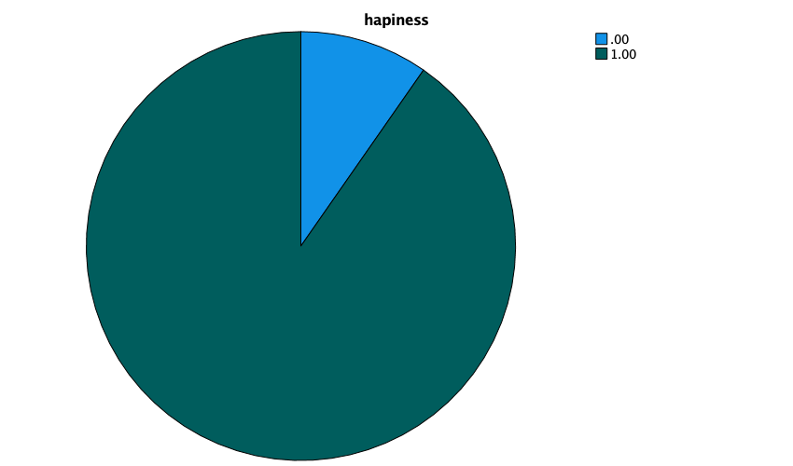

DATASET ACTIVATE DataSet1.

SAVE OUTFILE='/Users/liuzhibo/Desktop/wave/wave_7_elsa_data.sav'

/COMPRESSED.

RECODE indager (50 thru 59=1) (60 thru 69=2) (70 thru 79=3) (80 thru 89=4) INTO indager_da.

VARIABLE LABELS indager_da 'age group'.

EXECUTE.

FREQUENCIES VARIABLES=indager_da

/STATISTICS=RANGE MEAN MEDIAN MODE SUM

/HISTOGRAM

/ORDER=ANALYSIS.

**Frequencies**

|  |  |  |
| --- | --- | --- |
| **Notes** | | |
| Output Created | | 01-JAN-2022 15:56:18 |
| Comments | |  |
| Input | Data | /Users/liuzhibo/Desktop/wave/wave_7_elsa_data.sav |
| Active Dataset | DataSet1 |
| Filter | <none> |
| Weight | <none> |
| Split File | <none> |
| N of Rows in Working Data File | 9666 |
| Missing Value Handling | Definition of Missing | User-defined missing values are treated as missing. |
| Cases Used | Statistics are based on all cases with valid data. |
| Syntax | | FREQUENCIES VARIABLES=indager_da  /STATISTICS=RANGE MEAN MEDIAN MODE SUM  /HISTOGRAM  /ORDER=ANALYSIS. |
| Resources | Processor Time | 00:00:00.79 |
| Elapsed Time | 00:00:00.00 |

|  |  |  |
| --- | --- | --- |
| **Statistics** | | |
| age group | | |
| N | Valid | 9298 |
| Missing | 368 |
| Mean | | 2.2769 |
| Median | | 2.0000 |
| Mode | | 2.00 |
| Range | | 3.00 |
| Sum | | 21171.00 |

|  |  |  |  |  |  |
| --- | --- | --- | --- | --- | --- |
| **age group** | | | | | |
|  | | Frequency | Percent | Valid Percent | Cumulative Percent |
| Valid | 1.00 | 2082 | 21.5 | 22.4 | 22.4 |
| 2.00 | 3630 | 37.6 | 39.0 | 61.4 |
| 3.00 | 2515 | 26.0 | 27.0 | 88.5 |
| 4.00 | 1071 | 11.1 | 11.5 | 100.0 |
| Total | 9298 | 96.2 | 100.0 |  |
| Missing | System | 368 | 3.8 |  |  |
| Total | | 9666 | 100.0 |  |  |

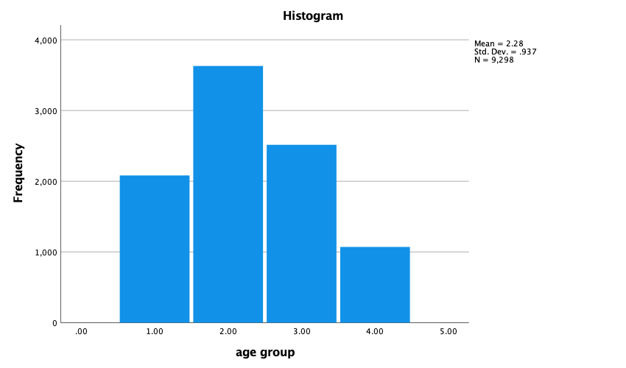

NPAR TESTS

/CHISQUARE=PScedD_da indager_da

/EXPECTED=EQUAL

/STATISTICS DESCRIPTIVES

/MISSING ANALYSIS.

**NPar Tests**

|  |  |  |
| --- | --- | --- |
| **Notes** | | |
| Output Created | | 01-JAN-2022 15:59:35 |
| Comments | |  |
| Input | Data | /Users/liuzhibo/Desktop/wave/wave_7_elsa_data.sav |
| Active Dataset | DataSet1 |
| Filter | <none> |
| Weight | <none> |
| Split File | <none> |
| N of Rows in Working Data File | 9666 |
| Missing Value Handling | Definition of Missing | User-defined missing values are treated as missing. |
| Cases Used | Statistics for each test are based on all cases with valid data for the variable(s) used in that test. |
| Syntax | | NPAR TESTS  /CHISQUARE=PScedD_da indager_da  /EXPECTED=EQUAL  /STATISTICS DESCRIPTIVES  /MISSING ANALYSIS. |
| Resources | Processor Time | 00:00:00.64 |
| Elapsed Time | 00:00:00.00 |
| Number of Cases Alloweda | 629145 |

|  |
| --- |
| a. Based on availability of workspace memory. |

|  |  |  |  |  |  |
| --- | --- | --- | --- | --- | --- |
| **Descriptive Statistics** | | | | | |
|  | N | Mean | Std. Deviation | Minimum | Maximum |
| hapiness | 8978 | .9032 | .29569 | .00 | 1.00 |
| age group | 9298 | 2.2769 | .93731 | 1.00 | 4.00 |

CROSSTABS

/TABLES=PScedD_da BY indager_da

/FORMAT=AVALUE TABLES

/STATISTICS=CHISQ

/CELLS=COUNT

/COUNT ROUND CELL.

**Crosstabs**

|  |  |  |
| --- | --- | --- |
| **Notes** | | |
| Output Created | | 01-JAN-2022 16:02:53 |
| Comments | |  |
| Input | Data | /Users/liuzhibo/Desktop/wave/wave_7_elsa_data.sav |
| Active Dataset | DataSet1 |
| Filter | <none> |
| Weight | <none> |
| Split File | <none> |
| N of Rows in Working Data File | 9666 |
| Missing Value Handling | Definition of Missing | User-defined missing values are treated as missing. |
| Cases Used | Statistics for each table are based on all the cases with valid data in the specified range(s) for all variables in each table. |
| Syntax | | CROSSTABS  /TABLES=PScedD_da BY indager_da  /FORMAT=AVALUE TABLES  /STATISTICS=CHISQ  /CELLS=COUNT  /COUNT ROUND CELL. |
| Resources | Processor Time | 00:00:00.65 |
| Elapsed Time | 00:00:01.00 |
| Dimensions Requested | 2 |
| Cells Available | 524245 |

|  |  |  |  |  |  |  |
| --- | --- | --- | --- | --- | --- | --- |
| **Case Processing Summary** | | | | | | |
|  | Cases | | | | | |
| Valid | | Missing | | Total | |
| N | Percent | N | Percent | N | Percent |
| hapiness * age group | 8688 | 89.9% | 978 | 10.1% | 9666 | 100.0% |

|  |  |  |  |  |  |  |
| --- | --- | --- | --- | --- | --- | --- |
| **hapiness * age group Crosstabulation** | | | | | | |
| Count | | | | | | |
|  | | age group | | | | Total |
| 1.00 | 2.00 | 3.00 | 4.00 |
| hapiness | .00 | 229 | 294 | 204 | 109 | 836 |
| 1.00 | 1701 | 3111 | 2169 | 871 | 7852 |
| Total | | 1930 | 3405 | 2373 | 980 | 8688 |

|  |  |  |  |
| --- | --- | --- | --- |
| **Chi-Square Tests** | | | |
|  | Value | df | Asymptotic Significance (2-sided) |
| Pearson Chi-Square | 20.393a | 3 | .000 |
| Likelihood Ratio | 19.809 | 3 | .000 |
| Linear-by-Linear Association | 2.223 | 1 | .136 |
| N of Valid Cases | 8688 |  |  |

|  |
| --- |
| a. 0 cells (0.0%) have expected count less than 5. The minimum expected count is 94.30. |

RECODE indsex (1=1) (2=0) INTO indsex_da.

VARIABLE LABELS indsex_da 'gender'.

EXECUTE.

FREQUENCIES VARIABLES=indsex_da

/STATISTICS=RANGE MEAN MEDIAN MODE SUM

/PIECHART FREQ

/ORDER=ANALYSIS.

**Frequencies**

|  |  |  |
| --- | --- | --- |
| **Notes** | | |
| Output Created | | 01-JAN-2022 16:13:08 |
| Comments | |  |
| Input | Data | /Users/liuzhibo/Desktop/wave/wave_7_elsa_data.sav |
| Active Dataset | DataSet1 |
| Filter | <none> |
| Weight | <none> |
| Split File | <none> |
| N of Rows in Working Data File | 9666 |
| Missing Value Handling | Definition of Missing | User-defined missing values are treated as missing. |
| Cases Used | Statistics are based on all cases with valid data. |
| Syntax | | FREQUENCIES VARIABLES=indsex_da  /STATISTICS=RANGE MEAN MEDIAN MODE SUM  /PIECHART FREQ  /ORDER=ANALYSIS. |
| Resources | Processor Time | 00:00:00.76 |
| Elapsed Time | 00:00:01.00 |

|  |  |  |
| --- | --- | --- |
| **Statistics** | | |
| gender | | |
| N | Valid | 9666 |
| Missing | 0 |
| Mean | | .4447 |
| Median | | .0000 |
| Mode | | .00 |
| Range | | 1.00 |
| Sum | | 4298.00 |

|  |  |  |  |  |  |
| --- | --- | --- | --- | --- | --- |
| **gender** | | | | | |
|  | | Frequency | Percent | Valid Percent | Cumulative Percent |
| Valid | .00 | 5368 | 55.5 | 55.5 | 55.5 |
| 1.00 | 4298 | 44.5 | 44.5 | 100.0 |
| Total | 9666 | 100.0 | 100.0 |  |

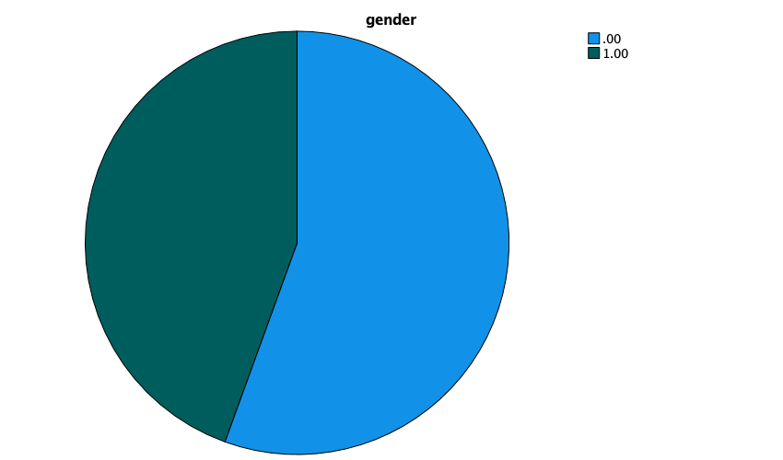

CROSSTABS

/TABLES=PScedD_da BY indsex_da

/FORMAT=AVALUE TABLES

/STATISTICS=CHISQ

/CELLS=COUNT

/COUNT ROUND CELL.

**Crosstabs**

|  |  |  |
| --- | --- | --- |
| **Notes** | | |
| Output Created | | 01-JAN-2022 16:14:05 |
| Comments | |  |
| Input | Data | /Users/liuzhibo/Desktop/wave/wave_7_elsa_data.sav |
| Active Dataset | DataSet1 |
| Filter | <none> |
| Weight | <none> |
| Split File | <none> |
| N of Rows in Working Data File | 9666 |
| Missing Value Handling | Definition of Missing | User-defined missing values are treated as missing. |
| Cases Used | Statistics for each table are based on all the cases with valid data in the specified range(s) for all variables in each table. |
| Syntax | | CROSSTABS  /TABLES=PScedD_da BY indsex_da  /FORMAT=AVALUE TABLES  /STATISTICS=CHISQ  /CELLS=COUNT  /COUNT ROUND CELL. |
| Resources | Processor Time | 00:00:00.66 |
| Elapsed Time | 00:00:01.00 |
| Dimensions Requested | 2 |
| Cells Available | 524245 |

|  |  |  |  |  |  |  |
| --- | --- | --- | --- | --- | --- | --- |
| **Case Processing Summary** | | | | | | |
|  | Cases | | | | | |
| Valid | | Missing | | Total | |
| N | Percent | N | Percent | N | Percent |
| hapiness * gender | 8978 | 92.9% | 688 | 7.1% | 9666 | 100.0% |

|  |  |  |  |  |
| --- | --- | --- | --- | --- |
| **hapiness * gender Crosstabulation** | | | | |
| Count | | | | |
|  | | gender | | Total |
| .00 | 1.00 |
| hapiness | .00 | 537 | 332 | 869 |
| 1.00 | 4506 | 3603 | 8109 |
| Total | | 5043 | 3935 | 8978 |

|  |  |  |  |  |  |
| --- | --- | --- | --- | --- | --- |
| **Chi-Square Tests** | | | | | |
|  | Value | df | Asymptotic Significance (2-sided) | Exact Sig. (2-sided) | Exact Sig. (1-sided) |
| Pearson Chi-Square | 12.363a | 1 | .000 |  |  |
| Continuity Correctionb | 12.112 | 1 | .001 |  |  |
| Likelihood Ratio | 12.493 | 1 | .000 |  |  |
| Fisher's Exact Test |  |  |  | .000 | .000 |
| Linear-by-Linear Association | 12.362 | 1 | .000 |  |  |
| N of Valid Cases | 8978 |  |  |  |  |

|  |
| --- |
| a. 0 cells (0.0%) have expected count less than 5. The minimum expected count is 380.88. |
| b. Computed only for a 2x2 table |

RECODE gcinhh (1=1) (2=0) INTO gcinhh_da.

VARIABLE LABELS gcinhh_da 'living with grandchildren'.

EXECUTE.

FREQUENCIES VARIABLES=gcinhh_da

/STATISTICS=RANGE MEAN MEDIAN MODE SUM

/PIECHART FREQ

/ORDER=ANALYSIS.

**Frequencies**

|  |  |  |
| --- | --- | --- |
| **Notes** | | |
| Output Created | | 01-JAN-2022 16:23:17 |
| Comments | |  |
| Input | Data | /Users/liuzhibo/Desktop/wave/wave_7_elsa_data.sav |
| Active Dataset | DataSet1 |
| Filter | <none> |
| Weight | <none> |
| Split File | <none> |
| N of Rows in Working Data File | 9666 |
| Missing Value Handling | Definition of Missing | User-defined missing values are treated as missing. |
| Cases Used | Statistics are based on all cases with valid data. |
| Syntax | | FREQUENCIES VARIABLES=gcinhh_da  /STATISTICS=RANGE MEAN MEDIAN MODE SUM  /PIECHART FREQ  /ORDER=ANALYSIS. |
| Resources | Processor Time | 00:00:00.81 |
| Elapsed Time | 00:00:00.00 |

|  |  |  |
| --- | --- | --- |
| **Statistics** | | |
| living with grandchildren | | |
| N | Valid | 9666 |
| Missing | 0 |
| Mean | | .0245 |
| Median | | .0000 |
| Mode | | .00 |
| Range | | 1.00 |
| Sum | | 237.00 |

|  |  |  |  |  |  |
| --- | --- | --- | --- | --- | --- |
| **living with grandchildren** | | | | | |
|  | | Frequency | Percent | Valid Percent | Cumulative Percent |
| Valid | .00 | 9429 | 97.5 | 97.5 | 97.5 |
| 1.00 | 237 | 2.5 | 2.5 | 100.0 |
| Total | 9666 | 100.0 | 100.0 |  |

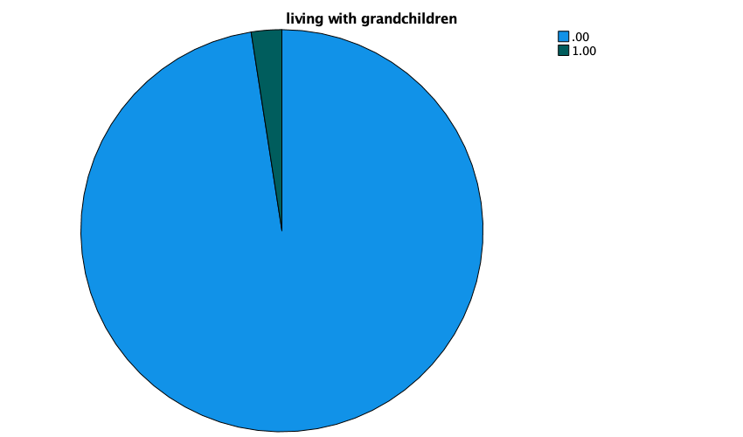

CROSSTABS

/TABLES=PScedD_da BY gcinhh_da

/FORMAT=AVALUE TABLES

/STATISTICS=CHISQ

/CELLS=COUNT

/COUNT ROUND CELL.

**Crosstabs**

|  |  |  |
| --- | --- | --- |
| **Notes** | | |
| Output Created | | 01-JAN-2022 16:24:29 |
| Comments | |  |
| Input | Data | /Users/liuzhibo/Desktop/wave/wave_7_elsa_data.sav |
| Active Dataset | DataSet1 |
| Filter | <none> |
| Weight | <none> |
| Split File | <none> |
| N of Rows in Working Data File | 9666 |
| Missing Value Handling | Definition of Missing | User-defined missing values are treated as missing. |
| Cases Used | Statistics for each table are based on all the cases with valid data in the specified range(s) for all variables in each table. |
| Syntax | | CROSSTABS  /TABLES=PScedD_da BY gcinhh_da  /FORMAT=AVALUE TABLES  /STATISTICS=CHISQ  /CELLS=COUNT  /COUNT ROUND CELL. |
| Resources | Processor Time | 00:00:00.70 |
| Elapsed Time | 00:00:00.00 |
| Dimensions Requested | 2 |
| Cells Available | 524245 |

|  |  |  |  |  |  |  |
| --- | --- | --- | --- | --- | --- | --- |
| **Case Processing Summary** | | | | | | |
|  | Cases | | | | | |
| Valid | | Missing | | Total | |
| N | Percent | N | Percent | N | Percent |
| hapiness * living with grandchildren | 8978 | 92.9% | 688 | 7.1% | 9666 | 100.0% |

|  |  |  |  |  |
| --- | --- | --- | --- | --- |
| **hapiness * living with grandchildren Crosstabulation** | | | | |
| Count | | | | |
|  | | living with grandchildren | | Total |
| .00 | 1.00 |
| hapiness | .00 | 839 | 30 | 869 |
| 1.00 | 7926 | 183 | 8109 |
| Total | | 8765 | 213 | 8978 |

|  |  |  |  |  |  |
| --- | --- | --- | --- | --- | --- |
| **Chi-Square Tests** | | | | | |
|  | Value | df | Asymptotic Significance (2-sided) | Exact Sig. (2-sided) | Exact Sig. (1-sided) |
| Pearson Chi-Square | 4.843a | 1 | .028 |  |  |
| Continuity Correctionb | 4.341 | 1 | .037 |  |  |
| Likelihood Ratio | 4.320 | 1 | .038 |  |  |
| Fisher's Exact Test |  |  |  | .034 | .023 |
| Linear-by-Linear Association | 4.843 | 1 | .028 |  |  |
| N of Valid Cases | 8978 |  |  |  |  |

|  |
| --- |
| a. 0 cells (0.0%) have expected count less than 5. The minimum expected count is 20.62. |
| b. Computed only for a 2x2 table |

RECODE HeLWk (1=1) (2=0) INTO HeLWk_da.

VARIABLE LABELS HeLWk_da 'disability'.

EXECUTE.

FREQUENCIES VARIABLES=HeLWk_da

/STATISTICS=RANGE MEAN MEDIAN MODE SUM

/PIECHART FREQ

/ORDER=ANALYSIS.

**Frequencies**

|  |  |  |
| --- | --- | --- |
| **Notes** | | |
| Output Created | | 01-JAN-2022 16:31:11 |
| Comments | |  |
| Input | Data | /Users/liuzhibo/Desktop/wave/wave_7_elsa_data.sav |
| Active Dataset | DataSet1 |
| Filter | <none> |
| Weight | <none> |
| Split File | <none> |
| N of Rows in Working Data File | 9666 |
| Missing Value Handling | Definition of Missing | User-defined missing values are treated as missing. |
| Cases Used | Statistics are based on all cases with valid data. |
| Syntax | | FREQUENCIES VARIABLES=HeLWk_da  /STATISTICS=RANGE MEAN MEDIAN MODE SUM  /PIECHART FREQ  /ORDER=ANALYSIS. |
| Resources | Processor Time | 00:00:00.78 |
| Elapsed Time | 00:00:01.00 |

|  |  |  |
| --- | --- | --- |
| **Statistics** | | |
| disability | | |
| N | Valid | 9057 |
| Missing | 609 |
| Mean | | .2984 |
| Median | | .0000 |
| Mode | | .00 |
| Range | | 1.00 |
| Sum | | 2703.00 |

|  |  |  |  |  |  |
| --- | --- | --- | --- | --- | --- |
| **disability** | | | | | |
|  | | Frequency | Percent | Valid Percent | Cumulative Percent |
| Valid | .00 | 6354 | 65.7 | 70.2 | 70.2 |
| 1.00 | 2703 | 28.0 | 29.8 | 100.0 |
| Total | 9057 | 93.7 | 100.0 |  |
| Missing | System | 609 | 6.3 |  |  |
| Total | | 9666 | 100.0 |  |  |

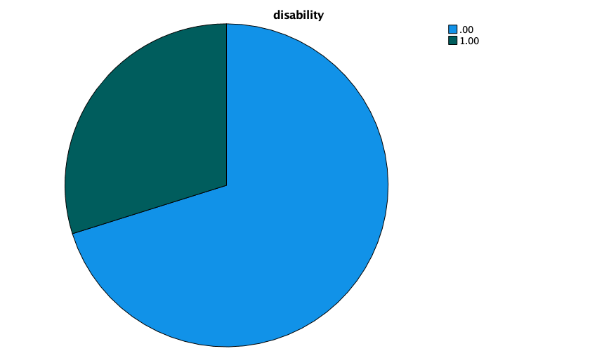

CROSSTABS

/TABLES=PScedD_da BY HeLWk_da

/FORMAT=AVALUE TABLES

/STATISTICS=CHISQ

/CELLS=COUNT

/COUNT ROUND CELL.

**Crosstabs**

|  |  |  |
| --- | --- | --- |
| **Notes** | | |
| Output Created | | 01-JAN-2022 16:31:49 |
| Comments | |  |
| Input | Data | /Users/liuzhibo/Desktop/wave/wave_7_elsa_data.sav |
| Active Dataset | DataSet1 |
| Filter | <none> |
| Weight | <none> |
| Split File | <none> |
| N of Rows in Working Data File | 9666 |
| Missing Value Handling | Definition of Missing | User-defined missing values are treated as missing. |
| Cases Used | Statistics for each table are based on all the cases with valid data in the specified range(s) for all variables in each table. |
| Syntax | | CROSSTABS  /TABLES=PScedD_da BY HeLWk_da  /FORMAT=AVALUE TABLES  /STATISTICS=CHISQ  /CELLS=COUNT  /COUNT ROUND CELL. |
| Resources | Processor Time | 00:00:00.72 |
| Elapsed Time | 00:00:01.00 |
| Dimensions Requested | 2 |
| Cells Available | 524245 |

|  |  |  |  |  |  |  |
| --- | --- | --- | --- | --- | --- | --- |
| **Case Processing Summary** | | | | | | |
|  | Cases | | | | | |
| Valid | | Missing | | Total | |
| N | Percent | N | Percent | N | Percent |
| hapiness * disability | 8967 | 92.8% | 699 | 7.2% | 9666 | 100.0% |

|  |  |  |  |  |
| --- | --- | --- | --- | --- |
| **hapiness * disability Crosstabulation** | | | | |
| Count | | | | |
|  | | disability | | Total |
| .00 | 1.00 |
| hapiness | .00 | 416 | 452 | 868 |
| 1.00 | 5891 | 2208 | 8099 |
| Total | | 6307 | 2660 | 8967 |

|  |  |  |  |  |  |
| --- | --- | --- | --- | --- | --- |
| **Chi-Square Tests** | | | | | |
|  | Value | df | Asymptotic Significance (2-sided) | Exact Sig. (2-sided) | Exact Sig. (1-sided) |
| Pearson Chi-Square | 231.306a | 1 | .000 |  |  |
| Continuity Correctionb | 230.118 | 1 | .000 |  |  |
| Likelihood Ratio | 212.286 | 1 | .000 |  |  |
| Fisher's Exact Test |  |  |  | .000 | .000 |
| Linear-by-Linear Association | 231.280 | 1 | .000 |  |  |
| N of Valid Cases | 8967 |  |  |  |  |

|  |
| --- |
| a. 0 cells (0.0%) have expected count less than 5. The minimum expected count is 257.49. |
| b. Computed only for a 2x2 table |

RECODE WpRAge (50 thru 59=1) (60 thru 69=2) (70 thru 79=3) (80 thru 89=4) INTO WpRAge_da.

VARIABLE LABELS WpRAge_da 'retire age'.

EXECUTE.

FREQUENCIES VARIABLES=HeLWk_da

/STATISTICS=RANGE MEAN MEDIAN MODE SUM

/HISTOGRAM

/ORDER=ANALYSIS.

**Frequencies**

|  |  |  |
| --- | --- | --- |
| **Notes** | | |
| Output Created | | 01-JAN-2022 16:40:04 |
| Comments | |  |
| Input | Data | /Users/liuzhibo/Desktop/wave/wave_7_elsa_data.sav |
| Active Dataset | DataSet1 |
| Filter | <none> |
| Weight | <none> |
| Split File | <none> |
| N of Rows in Working Data File | 9666 |
| Missing Value Handling | Definition of Missing | User-defined missing values are treated as missing. |
| Cases Used | Statistics are based on all cases with valid data. |
| Syntax | | FREQUENCIES VARIABLES=HeLWk_da  /STATISTICS=RANGE MEAN MEDIAN MODE SUM  /HISTOGRAM  /ORDER=ANALYSIS. |
| Resources | Processor Time | 00:00:00.80 |
| Elapsed Time | 00:00:01.00 |

|  |  |  |
| --- | --- | --- |
| **Statistics** | | |
| disability | | |
| N | Valid | 9057 |
| Missing | 609 |
| Mean | | .2984 |
| Median | | .0000 |
| Mode | | .00 |
| Range | | 1.00 |
| Sum | | 2703.00 |

|  |  |  |  |  |  |
| --- | --- | --- | --- | --- | --- |
| **disability** | | | | | |
|  | | Frequency | Percent | Valid Percent | Cumulative Percent |
| Valid | .00 | 6354 | 65.7 | 70.2 | 70.2 |
| 1.00 | 2703 | 28.0 | 29.8 | 100.0 |
| Total | 9057 | 93.7 | 100.0 |  |
| Missing | System | 609 | 6.3 |  |  |
| Total | | 9666 | 100.0 |  |  |

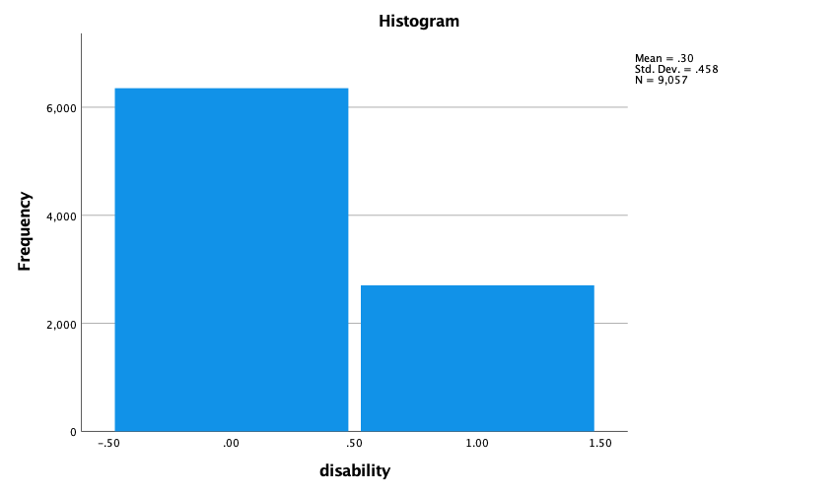

FREQUENCIES VARIABLES=WpRAge_da

/STATISTICS=RANGE MEAN MEDIAN MODE SUM

/HISTOGRAM

/ORDER=ANALYSIS.

**Frequencies**

|  |  |  |
| --- | --- | --- |
| **Notes** | | |
| Output Created | | 01-JAN-2022 16:40:42 |
| Comments | |  |
| Input | Data | /Users/liuzhibo/Desktop/wave/wave_7_elsa_data.sav |
| Active Dataset | DataSet1 |
| Filter | <none> |
| Weight | <none> |
| Split File | <none> |
| N of Rows in Working Data File | 9666 |
| Missing Value Handling | Definition of Missing | User-defined missing values are treated as missing. |
| Cases Used | Statistics are based on all cases with valid data. |
| Syntax | | FREQUENCIES VARIABLES=WpRAge_da  /STATISTICS=RANGE MEAN MEDIAN MODE SUM  /HISTOGRAM  /ORDER=ANALYSIS. |
| Resources | Processor Time | 00:00:00.80 |
| Elapsed Time | 00:00:01.00 |

|  |  |  |
| --- | --- | --- |
| **Statistics** | | |
| retire age | | |
| N | Valid | 954 |
| Missing | 8712 |
| Mean | | 1.7704 |
| Median | | 2.0000 |
| Mode | | 2.00 |
| Range | | 3.00 |
| Sum | | 1689.00 |

|  |  |  |  |  |  |
| --- | --- | --- | --- | --- | --- |
| **retire age** | | | | | |
|  | | Frequency | Percent | Valid Percent | Cumulative Percent |
| Valid | 1.00 | 273 | 2.8 | 28.6 | 28.6 |
| 2.00 | 632 | 6.5 | 66.2 | 94.9 |
| 3.00 | 44 | .5 | 4.6 | 99.5 |
| 4.00 | 5 | .1 | .5 | 100.0 |
| Total | 954 | 9.9 | 100.0 |  |
| Missing | System | 8712 | 90.1 |  |  |
| Total | | 9666 | 100.0 |  |  |

CROSSTABS

/TABLES=PScedD_da BY WpRAge_da

/FORMAT=AVALUE TABLES

/STATISTICS=CHISQ

/CELLS=COUNT

/COUNT ROUND CELL.

**Crosstabs**

|  |  |  |
| --- | --- | --- |
| **Notes** | | |
| Output Created | | 01-JAN-2022 16:41:34 |
| Comments | |  |
| Input | Data | /Users/liuzhibo/Desktop/wave/wave_7_elsa_data.sav |
| Active Dataset | DataSet1 |
| Filter | <none> |
| Weight | <none> |
| Split File | <none> |
| N of Rows in Working Data File | 9666 |
| Missing Value Handling | Definition of Missing | User-defined missing values are treated as missing. |
| Cases Used | Statistics for each table are based on all the cases with valid data in the specified range(s) for all variables in each table. |
| Syntax | | CROSSTABS  /TABLES=PScedD_da BY WpRAge_da  /FORMAT=AVALUE TABLES  /STATISTICS=CHISQ  /CELLS=COUNT  /COUNT ROUND CELL. |
| Resources | Processor Time | 00:00:00.73 |
| Elapsed Time | 00:00:01.00 |
| Dimensions Requested | 2 |
| Cells Available | 524245 |

|  |  |  |  |  |  |  |
| --- | --- | --- | --- | --- | --- | --- |
| **Case Processing Summary** | | | | | | |
|  | Cases | | | | | |
| Valid | | Missing | | Total | |
| N | Percent | N | Percent | N | Percent |
| hapiness * retire age | 858 | 8.9% | 8808 | 91.1% | 9666 | 100.0% |

|  |  |  |  |  |  |  |
| --- | --- | --- | --- | --- | --- | --- |
| **hapiness * retire age Crosstabulation** | | | | | | |
| Count | | | | | | |
|  | | retire age | | | | Total |
| 1.00 | 2.00 | 3.00 | 4.00 |
| hapiness | .00 | 19 | 41 | 1 | 0 | 61 |
| 1.00 | 227 | 525 | 41 | 4 | 797 |
| Total | | 246 | 566 | 42 | 4 | 858 |

|  |  |  |  |
| --- | --- | --- | --- |
| **Chi-Square Tests** | | | |
|  | Value | df | Asymptotic Significance (2-sided) |
| Pearson Chi-Square | 1.884a | 3 | .597 |
| Likelihood Ratio | 2.626 | 3 | .453 |
| Linear-by-Linear Association | .964 | 1 | .326 |
| N of Valid Cases | 858 |  |  |

|  |
| --- |
| a. 3 cells (37.5%) have expected count less than 5. The minimum expected count is .28. |

RECODE DiMar (1=1) (2=2) (6=3) (7=0) INTO DiMar_da.

VARIABLE LABELS DiMar_da 'Marital status'.

EXECUTE.

FREQUENCIES VARIABLES=DiMar_da

/STATISTICS=RANGE MEAN MEDIAN MODE SUM

/HISTOGRAM

/ORDER=ANALYSIS.

**Frequencies**

|  |  |  |
| --- | --- | --- |
| **Notes** | | |
| Output Created | | 01-JAN-2022 16:49:36 |
| Comments | |  |
| Input | Data | /Users/liuzhibo/Desktop/wave/wave_7_elsa_data.sav |
| Active Dataset | DataSet1 |
| Filter | <none> |
| Weight | <none> |
| Split File | <none> |
| N of Rows in Working Data File | 9666 |
| Missing Value Handling | Definition of Missing | User-defined missing values are treated as missing. |
| Cases Used | Statistics are based on all cases with valid data. |
| Syntax | | FREQUENCIES VARIABLES=DiMar_da  /STATISTICS=RANGE MEAN MEDIAN MODE SUM  /HISTOGRAM  /ORDER=ANALYSIS. |
| Resources | Processor Time | 00:00:00.79 |
| Elapsed Time | 00:00:00.00 |

|  |  |  |
| --- | --- | --- |
| **Statistics** | | |
| Marital status | | |
| N | Valid | 8470 |
| Missing | 1196 |
| Mean | | 1.7220 |
| Median | | 2.0000 |
| Mode | | 2.00 |
| Range | | 3.00 |
| Sum | | 14585.00 |

|  |  |  |  |  |  |
| --- | --- | --- | --- | --- | --- |
| **Marital status** | | | | | |
|  | | Frequency | Percent | Valid Percent | Cumulative Percent |
| Valid | .00 | 1405 | 14.5 | 16.6 | 16.6 |
| 1.00 | 624 | 6.5 | 7.4 | 24.0 |
| 2.00 | 5362 | 55.5 | 63.3 | 87.3 |
| 3.00 | 1079 | 11.2 | 12.7 | 100.0 |
| Total | 8470 | 87.6 | 100.0 |  |
| Missing | System | 1196 | 12.4 |  |  |
| Total | | 9666 | 100.0 |  |  |

CROSSTABS

/TABLES=PScedD_da BY DiMar_da

/FORMAT=AVALUE TABLES

/STATISTICS=CHISQ

/CELLS=COUNT

/COUNT ROUND CELL.

**Crosstabs**

|  |  |  |
| --- | --- | --- |
| **Notes** | | |
| Output Created | | 01-JAN-2022 16:50:30 |
| Comments | |  |
| Input | Data | /Users/liuzhibo/Desktop/wave/wave_7_elsa_data.sav |
| Active Dataset | DataSet1 |
| Filter | <none> |
| Weight | <none> |
| Split File | <none> |
| N of Rows in Working Data File | 9666 |
| Missing Value Handling | Definition of Missing | User-defined missing values are treated as missing. |
| Cases Used | Statistics for each table are based on all the cases with valid data in the specified range(s) for all variables in each table. |
| Syntax | | CROSSTABS  /TABLES=PScedD_da BY DiMar_da  /FORMAT=AVALUE TABLES  /STATISTICS=CHISQ  /CELLS=COUNT  /COUNT ROUND CELL. |
| Resources | Processor Time | 00:00:00.72 |
| Elapsed Time | 00:00:01.00 |
| Dimensions Requested | 2 |
| Cells Available | 524245 |

|  |  |  |  |  |  |  |
| --- | --- | --- | --- | --- | --- | --- |
| **Case Processing Summary** | | | | | | |
|  | Cases | | | | | |
| Valid | | Missing | | Total | |
| N | Percent | N | Percent | N | Percent |
| hapiness * Marital status | 7856 | 81.3% | 1810 | 18.7% | 9666 | 100.0% |

|  |  |  |  |  |  |  |
| --- | --- | --- | --- | --- | --- | --- |
| **hapiness * Marital status Crosstabulation** | | | | | | |
| Count | | | | | | |
|  | | Marital status | | | | Total |
| .00 | 1.00 | 2.00 | 3.00 |
| hapiness | .00 | 174 | 103 | 358 | 149 | 784 |
| 1.00 | 1143 | 489 | 4554 | 886 | 7072 |
| Total | | 1317 | 592 | 4912 | 1035 | 7856 |

|  |  |  |  |
| --- | --- | --- | --- |
| **Chi-Square Tests** | | | |
|  | Value | df | Asymptotic Significance (2-sided) |
| Pearson Chi-Square | 113.663a | 3 | .000 |
| Likelihood Ratio | 107.773 | 3 | .000 |
| Linear-by-Linear Association | 12.304 | 1 | .000 |
| N of Valid Cases | 7856 |  |  |

|  |
| --- |
| a. 0 cells (0.0%) have expected count less than 5. The minimum expected count is 59.08. |

RECODE PScedA (1=1) (2=0) INTO PScedA_da.

VARIABLE LABELS PScedA_da 'depression'.

EXECUTE.

FREQUENCIES VARIABLES=PScedA_da

/STATISTICS=RANGE MEAN MEDIAN MODE SUM

/PIECHART FREQ

/ORDER=ANALYSIS.

**Frequencies**

|  |  |  |
| --- | --- | --- |
| **Notes** | | |
| Output Created | | 01-JAN-2022 17:02:31 |
| Comments | |  |
| Input | Data | /Users/liuzhibo/Desktop/wave/wave_7_elsa_data.sav |
| Active Dataset | DataSet1 |
| Filter | <none> |
| Weight | <none> |
| Split File | <none> |
| N of Rows in Working Data File | 9666 |
| Missing Value Handling | Definition of Missing | User-defined missing values are treated as missing. |
| Cases Used | Statistics are based on all cases with valid data. |
| Syntax | | FREQUENCIES VARIABLES=PScedA_da  /STATISTICS=RANGE MEAN MEDIAN MODE SUM  /PIECHART FREQ  /ORDER=ANALYSIS. |
| Resources | Processor Time | 00:00:00.84 |
| Elapsed Time | 00:00:01.00 |

|  |  |  |
| --- | --- | --- |
| **Statistics** | | |
| depression | | |
| N | Valid | 9001 |
| Missing | 665 |
| Mean | | .1159 |
| Median | | .0000 |
| Mode | | .00 |
| Range | | 1.00 |
| Sum | | 1043.00 |

|  |  |  |  |  |  |
| --- | --- | --- | --- | --- | --- |
| **depression** | | | | | |
|  | | Frequency | Percent | Valid Percent | Cumulative Percent |
| Valid | .00 | 7958 | 82.3 | 88.4 | 88.4 |
| 1.00 | 1043 | 10.8 | 11.6 | 100.0 |
| Total | 9001 | 93.1 | 100.0 |  |
| Missing | System | 665 | 6.9 |  |  |
| Total | | 9666 | 100.0 |  |  |

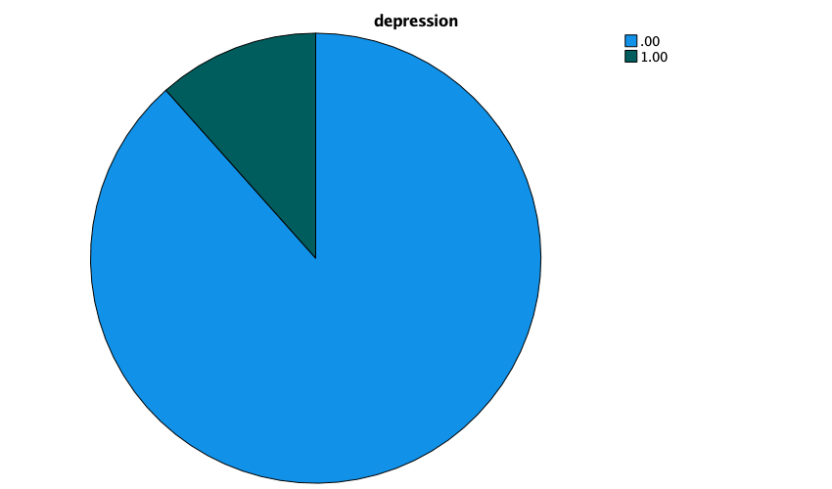

CROSSTABS

/TABLES=PScedD_da BY PScedA_da

/FORMAT=AVALUE TABLES

/STATISTICS=CHISQ

/CELLS=COUNT

/COUNT ROUND CELL.

**Crosstabs**

|  |  |  |
| --- | --- | --- |
| **Notes** | | |
| Output Created | | 01-JAN-2022 17:03:11 |
| Comments | |  |
| Input | Data | /Users/liuzhibo/Desktop/wave/wave_7_elsa_data.sav |
| Active Dataset | DataSet1 |
| Filter | <none> |
| Weight | <none> |
| Split File | <none> |
| N of Rows in Working Data File | 9666 |
| Missing Value Handling | Definition of Missing | User-defined missing values are treated as missing. |
| Cases Used | Statistics for each table are based on all the cases with valid data in the specified range(s) for all variables in each table. |
| Syntax | | CROSSTABS  /TABLES=PScedD_da BY PScedA_da  /FORMAT=AVALUE TABLES  /STATISTICS=CHISQ  /CELLS=COUNT  /COUNT ROUND CELL. |
| Resources | Processor Time | 00:00:00.73 |
| Elapsed Time | 00:00:01.00 |
| Dimensions Requested | 2 |
| Cells Available | 524245 |

|  |  |  |  |  |  |  |
| --- | --- | --- | --- | --- | --- | --- |
| **Case Processing Summary** | | | | | | |
|  | Cases | | | | | |
| Valid | | Missing | | Total | |
| N | Percent | N | Percent | N | Percent |
| hapiness * depression | 8977 | 92.9% | 689 | 7.1% | 9666 | 100.0% |

|  |  |  |  |  |
| --- | --- | --- | --- | --- |
| **hapiness * depression Crosstabulation** | | | | |
| Count | | | | |
|  | | depression | | Total |
| .00 | 1.00 |
| hapiness | .00 | 371 | 497 | 868 |
| 1.00 | 7566 | 543 | 8109 |
| Total | | 7937 | 1040 | 8977 |

|  |  |  |  |  |  |
| --- | --- | --- | --- | --- | --- |
| **Chi-Square Tests** | | | | | |
|  | Value | df | Asymptotic Significance (2-sided) | Exact Sig. (2-sided) | Exact Sig. (1-sided) |
| Pearson Chi-Square | 1956.922a | 1 | .000 |  |  |
| Continuity Correctionb | 1951.989 | 1 | .000 |  |  |
| Likelihood Ratio | 1268.018 | 1 | .000 |  |  |
| Fisher's Exact Test |  |  |  | .000 | .000 |
| Linear-by-Linear Association | 1956.704 | 1 | .000 |  |  |
| N of Valid Cases | 8977 |  |  |  |  |

|  |
| --- |
| a. 0 cells (0.0%) have expected count less than 5. The minimum expected count is 100.56. |
| b. Computed only for a 2x2 table |

LOGISTIC REGRESSION VARIABLES PScedD_da

/METHOD=ENTER PScedA_da indager_da indsex_da DiMar_da gcinhh_da HeLWk_da

/CONTRAST (PScedA_da)=Indicator

/CONTRAST (indager_da)=Indicator

/CONTRAST (indsex_da)=Indicator

/CONTRAST (DiMar_da)=Indicator

/CONTRAST (gcinhh_da)=Indicator

/CONTRAST (HeLWk_da)=Indicator

/PRINT=CI(95)

/CRITERIA=PIN(0.05) POUT(0.10) ITERATE(20) CUT(0.5).

**Logistic Regression**

|  |  |  |
| --- | --- | --- |
| **Notes** | | |
| Output Created | | 01-JAN-2022 17:08:36 |
| Comments | |  |
| Input | Data | /Users/liuzhibo/Desktop/wave/wave_7_elsa_data.sav |
| Active Dataset | DataSet1 |
| Filter | <none> |
| Weight | <none> |
| Split File | <none> |
| N of Rows in Working Data File | 9666 |
| Missing Value Handling | Definition of Missing | User-defined missing values are treated as missing |
| Syntax | | LOGISTIC REGRESSION VARIABLES PScedD_da  /METHOD=ENTER PScedA_da indager_da indsex_da DiMar_da gcinhh_da HeLWk_da  /CONTRAST (PScedA_da)=Indicator  /CONTRAST (indager_da)=Indicator  /CONTRAST (indsex_da)=Indicator  /CONTRAST (DiMar_da)=Indicator  /CONTRAST (gcinhh_da)=Indicator  /CONTRAST (HeLWk_da)=Indicator  /PRINT=CI(95)  /CRITERIA=PIN(0.05) POUT(0.10) ITERATE(20) CUT(0.5). |
| Resources | Processor Time | 00:00:01.44 |
| Elapsed Time | 00:00:02.00 |

|  |  |  |  |
| --- | --- | --- | --- |
| **Case Processing Summary** | | | |
| Unweighted Casesa | | N | Percent |
| Selected Cases | Included in Analysis | 7582 | 78.4 |
| Missing Cases | 2084 | 21.6 |
| Total | 9666 | 100.0 |
| Unselected Cases | | 0 | .0 |
| Total | | 9666 | 100.0 |

|  |
| --- |
| a. If weight is in effect, see classification table for the total number of cases. |

|  |  |
| --- | --- |
| **Dependent Variable Encoding** | |
| Original Value | Internal Value |
| .00 | 0 |
| 1.00 | 1 |

|  |  |  |  |  |  |
| --- | --- | --- | --- | --- | --- |
| **Categorical Variables Codings** | | | | | |
|  | | Frequency | Parameter coding | | |
| (1) | (2) | (3) |
| age group | 1.00 | 1631 | 1.000 | .000 | .000 |
| 2.00 | 2928 | .000 | 1.000 | .000 |
| 3.00 | 2104 | .000 | .000 | 1.000 |
| 4.00 | 919 | .000 | .000 | .000 |
| Marital status | .00 | 1213 | 1.000 | .000 | .000 |
| 1.00 | 557 | .000 | 1.000 | .000 |
| 2.00 | 4790 | .000 | .000 | 1.000 |
| 3.00 | 1022 | .000 | .000 | .000 |
| disability | .00 | 5360 | 1.000 |  |  |
| 1.00 | 2222 | .000 |  |  |
| gender | .00 | 4267 | 1.000 |  |  |
| 1.00 | 3315 | .000 |  |  |
| living with grandchildren | .00 | 7403 | 1.000 |  |  |
| 1.00 | 179 | .000 |  |  |
| depression | .00 | 6705 | 1.000 |  |  |
| 1.00 | 877 | .000 |  |  |

**Block 0: Beginning Block**

|  |  |  |  |  |  |
| --- | --- | --- | --- | --- | --- |
| **Classification Tablea,b** | | | | | |
|  | Observed | | Predicted | | |
| hapiness | | Percentage Correct |
| .00 | 1.00 |
| Step 0 | hapiness | .00 | 0 | 751 | .0 |
| 1.00 | 0 | 6831 | 100.0 |
| Overall Percentage | |  |  | 90.1 |

|  |
| --- |
| a. Constant is included in the model. |
| b. The cut value is .500 |

|  |  |  |  |  |  |  |  |
| --- | --- | --- | --- | --- | --- | --- | --- |
| **Variables in the Equation** | | | | | | | |
|  | | B | S.E. | Wald | df | Sig. | Exp(B) |
| Step 0 | Constant | 2.208 | .038 | 3298.132 | 1 | .000 | 9.096 |

|  |  |  |  |  |  |
| --- | --- | --- | --- | --- | --- |
| **Variables not in the Equation** | | | | | |
|  | | | Score | df | Sig. |
| Step 0 | Variables | depression(1) | 1671.575 | 1 | .000 |
| age group | 17.667 | 3 | .001 |
| age group(1) | 14.322 | 1 | .000 |
| age group(2) | 4.895 | 1 | .027 |
| age group(3) | 3.377 | 1 | .066 |
| gender(1) | 11.815 | 1 | .001 |
| Marital status | 114.161 | 3 | .000 |
| Marital status(1) | 16.600 | 1 | .000 |
| Marital status(2) | 41.711 | 1 | .000 |
| Marital status(3) | 104.822 | 1 | .000 |
| living with grandchildren(1) | 3.389 | 1 | .066 |
| disability(1) | 205.947 | 1 | .000 |
| Overall Statistics | | 1759.488 | 10 | .000 |

**Block 1: Method = Enter**

|  |  |  |  |  |
| --- | --- | --- | --- | --- |
| **Omnibus Tests of Model Coefficients** | | | | |
|  | | Chi-square | df | Sig. |
| Step 1 | Step | 1184.797 | 10 | .000 |
| Block | 1184.797 | 10 | .000 |
| Model | 1184.797 | 10 | .000 |

|  |  |  |  |
| --- | --- | --- | --- |
| **Model Summary** | | | |
| Step | -2 Log likelihood | Cox & Snell R Square | Nagelkerke R Square |
| 1 | 3713.045a | .145 | .304 |

|  |
| --- |
| a. Estimation terminated at iteration number 6 because parameter estimates changed by less than .001. |

|  |  |  |  |  |  |
| --- | --- | --- | --- | --- | --- |
| **Classification Tablea** | | | | | |
|  | Observed | | Predicted | | |
| hapiness | | Percentage Correct |
| .00 | 1.00 |
| Step 1 | hapiness | .00 | 227 | 524 | 30.2 |
| 1.00 | 170 | 6661 | 97.5 |
| Overall Percentage | |  |  | 90.8 |

|  |
| --- |
| a. The cut value is .500 |

|  |  |  |  |  |  |  |  |  |
| --- | --- | --- | --- | --- | --- | --- | --- | --- |
| **Variables in the Equation** | | | | | | | | |
|  | | B | S.E. | Wald | df | Sig. | Exp(B) | 95% C.I.for EXP(B) |
| Lower |
| Step 1a | depression(1) | 2.752 | .093 | 874.425 | 1 | .000 | 15.675 | 13.061 |
| age group |  |  | 14.346 | 3 | .002 |  |  |
| age group(1) | -.554 | .167 | 11.019 | 1 | .001 | .575 | .414 |
| age group(2) | -.318 | .154 | 4.238 | 1 | .040 | .728 | .538 |
| age group(3) | -.138 | .153 | .813 | 1 | .367 | .871 | .645 |
| gender(1) | -.049 | .093 | .284 | 1 | .594 | .952 | .794 |
| Marital status |  |  | 36.978 | 3 | .000 |  |  |
| Marital status(1) | .253 | .156 | 2.639 | 1 | .104 | 1.288 | .949 |
| Marital status(2) | -.303 | .170 | 3.170 | 1 | .075 | .738 | .529 |
| Marital status(3) | .485 | .123 | 15.639 | 1 | .000 | 1.624 | 1.277 |
| living with grandchildren(1) | .083 | .264 | .099 | 1 | .753 | 1.087 | .647 |
| disability(1) | .602 | .093 | 41.985 | 1 | .000 | 1.825 | 1.521 |
| Constant | -.250 | .320 | .610 | 1 | .435 | .779 |  |

|  |  |  |
| --- | --- | --- |
| **Variables in the Equation** | | |
|  | | 95% C.I.for EXP(B) |
| Upper |
| Step 1a | depression(1) | 18.811 |
| age group |  |
| age group(1) | .797 |
| age group(2) | .985 |
| age group(3) | 1.176 |
| gender(1) | 1.141 |
| Marital status |  |
| Marital status(1) | 1.749 |
| Marital status(2) | 1.031 |
| Marital status(3) | 2.065 |
| living with grandchildren(1) | 1.825 |
| disability(1) | 2.189 |
| Constant |  |

|  |
| --- |
| a. Variable(s) entered on step 1: depression, age group, gender, Marital status, living with grandchildren, disability. |